ED

ΕΛΛΗΝΙΚΗ ΔΗΜΟΚΡΑΤΙΑ

ΥΠΟΥΡΓΕΙΟ ΠΟΛΙΤΙΣΜΟΥ

ΓΡΑΦΕΙΟ ΤΥΠΟΥ

------

**PRESS PACK**

**The exhibition *Kykladitisses: Untold Stories of Women in the Cyclades***

**will inaugurate the Archaeological Museum of Thera, Santorini**

**June 21– October 31 2025**

The emblematic pan-cycladic exhibition ***Kykladitisses: Untold Stories of Women in the Cyclades****,* organized by the Museum of Cycladic Art and the Ministry of Culture (Ephorate of Antiquities of Cyclades) in Athens, will travel to Santorini to inaugurate the renovated Archaeological Museum of Thera. The exhibition that is co-organized by the Municipality of Thera will officially open its doors to the public on **June 21** and will remain on view until **October 31, 2025**.

The exhibition is the first joint action of the Museum of Cycladic Art and the Ephorate of Antiquities of Cyclades, in implementation of the Memorandum of Cooperation signed on May 17, 2024 by the Minister of Culture, Lina Mendoni, and the President and CEO of the Museum of Cycladic Art, Sandra Marinopoulou, with the aim of studying, highlighting and promoting the Cycladic culture in Greece and abroad. It is a unique initiative, as it is the first time an exhibition is co-organized by a state and a private museum in Greece.

The exhibition “Kykladitisses: Untold Stories of Women in the Cyclades”, presents history through the eyes of the women of the Cyclades, from antiquity to the 19th century. It brings together 180 unique masterpieces from almost all the islands of the Cyclades: Amorgos, Andros, Delos, Thera, Ios, Kea, Kythnos, Melos, Mykonos, Naxos, Paros, Seriphos, Sikinos, Siphnos, Syros, Tenos and Pholegandros. The exhibits date from early prehistory to the birth of the Greek state. Unique works, most of which have never travelled either outside the Cyclades or outside the Museum of Cycladic Art; some have never before been presented to the public. Alongside the marble Cycladic figurines of the Early Cycladic period from the Museum of Cycladic Art, 135 exhibits from the collections of the Ephorate of Antiquities of the Cyclades and artefacts from the Canellopoulos Museum, the Epigraphic Museum of Athens, the Ephorate of Paleoanthropology and Speleology and important private collections are on display.

The exhibition aims to examine the roles of women and their positions in insular societies, through smaller or larger "untold" stories that are told by the women themselves, either through their words or through their material remains, though almost always through the eyes of the men of their time. The exhibition thus brings to light unknown roles of women over time and how these roles were influenced by their insularity. Deities and mothers, priestesses, courtesans, merchants, fighters, intellectuals, mourners, witches, immigrants all take – all star in the show. The visitor will come to know the Cycladic women both in the public and private spheres, in social, political, religious, and family life.

Statuettes and large-sized sculptures, vases, jewellery, coins, funerary stelae, inscriptions with legal texts, frescoes, mosaics, engravings, manuscripts and icons – ranging from prehistoric to post-Byzantine times – compose the exhibition. From these exhibits, many of which could stand as individual objects of exhibition on their own, three works stand out due to their uniqueness and size: the colossal Kore of Thira (2.48 meters in height), one of the few nearly complete archaic statues; the emblematic fresco from Akrotiri on Santorini depicting the "Women in the Sanctuary," a unique and monumental work (nearly 4 meters in length); and the Hellenistic statue of the Stag-hunting Artemis from Delos, which is being exhibited outside the island for the first time.

In the Santorini exhibition, the curators added to the eroticism section a statue of Aphrodite adjusting her sandal from the Archaeological Museum of Thera, while the burial monument of Parthenika from Thera has been placed in such a way that the installation and its grave goods are in direct visual contact with the original monument displayed in the museum's atrium.

The curators of the exhibition are Dr Demetrios Athanasoulis, Director of the Ephorate of Antiquities of Cyclades, and the Academic Directors of the Museum of Cycladic Art, Dr Panagiotis P. Iossif, Professor at Radboud University in the Netherlands, and Dr Ioannis Fappas, Assistant Professor at the Aristotle University of Thessaloniki. The museological study of the exhibition was carried out by the three curators, and the architects Despoina Tsafou and Katerina Apostolou.

The exhibition catalogue consists of two volumes. The second volume (D. Athanasoulis - P. Iossif (eds), *Kykladitisses*. Untold stories of women in the Cyclades. Essays on the artefacts of the exhibition, Athens, 2025, 960 p.) aspires to become the bibliographic reference for archaeological and historical research in the Cyclades for the coming years. Moreover, it is the first catalogue of an archaeological exhibition in Greece with full photographic documentation of its entire installation in Athens**.**

For the exhibition in Santorini, as well as for that in Athens, the Museum of Cycladic Art created a complete bilingual audio guide, with narratives of the stories of the women of the Cyclades and the general line of the exhibition. In addition, selected artefacts are accompanied by a QR-code through which the visitor can read extensive and detailed information about the objects on the Cycladic Museum's mobile application.

**MORE INFORMATION ABOUT THE EXHIBITION**

Women and the multiple roles they played in ancient Greece have long been a subject of study. Ancient Greek women were largely marginalized; their lives were confined to the domestic sphere and their social contribution was diminished compared to that of men. While women were indeed subject to legal and social frameworks that sought to limit their autonomy, at the same time they held substantial positions in religious, economic and family spheres that allowed for the expression of some power and authority.

If one takes a closer look at the “Kykladitisses”, one will see that the roles of women in the insular society were largely shaped by the location of the place, the local traditions, and the wider cultural and political influences that dominated the region. While the women in the Cyclades, like their counterparts on the mainland, were restricted by the general patriarchal structures, the specific religious, social and economic contexts of the islands provided opportunities for female activity in the domestic, economic, and ritual sectors.

The main goal of the exhibition is to recover the narratives and stories of women who have contributed over time to the Cycladic community in various fields. By focusing on ‘unknown stories’, the exhibition seeks to challenge dominant gender stereotypes. In addition, the exhibition aims to promote an appreciation of the diverse experiences of women in the Cyclades, highlighting their contributions to family life, local economies, cultural traditions, and political life. This objective is in line with the demands of our times.

The importance of the “Kykladitisses” exhibition extends beyond the mere presentation of important artefacts, masterpieces or rare sources; it is a crucial effort to recognize the contribution of women to the social structure and cultural heritage of the Cyclades. Moreover, by highlighting these stories, a more comprehensive and inclusive understanding of the history of the islands is put forward, a history that does not ignore the crucial contribution of women.

The exhibition is structured around the following 12 sections:

1. Juggling between two genders

2. The origin of the world

3. Goddesses of the islands

4. Female apotropaic figures

5. In the sanctuaries

6. Goddesses of the sea

7. Women's identities

8. From the Oikoumene to the Archipelago

9. Eroticism

10. Violence

11. Death through their own eyes

12. Faces

**LENDERS OF ITEMS DISPLAYED**

Delos Archaeological Museum

Paros Archaeological Museum

Museum of Prehistoric Thera

Thera Archaeological Museum

Ios Archaeological Museum

Seriphos Archaeological Collection

Amorgos Archaeological Collection

Monastery of Panagia Chozoviotissa – Amorgos

Andros Archaeological Museum

Kythnos Archaeological Collection

Mykonos Archaeological Museum

Naxos Archaeological Museum

Siphnos Archaeological Museum

Tinos Archaeological Museum

Keas Archaeological Museum

Melos Archaeological Museum

Syros Archaeological Museum

Pholegandros Archaeological Collection

Sikinos Archaeological Collection

Kaireios Library – Andros

Paul and Alexandra Kanellopoulos Museum

Epigraphical Museum

National Library of Greece

General State Archives

Laskaridis Foundation Library

Benaki Museum

Ephorate of Paleoanthropology – Speleology

**About the Museum of Cycladic Art**

The Museum of Cycladic Art houses one of the most important and complete collections of Cycladic Art in the world. Cycladic Art flourished on the islands of the central and southern Aegean during the 3rd millennium BC.

The most well-known artefacts from this culture are marble female figurines, whose minimalistic and abstracted forms influenced 20th and 21st century artists such as Brancusi, Modigliani, Giacometti, Hepworth, Moore, and Ai Weiwei.

Committed to providing inspiration and impact to diverse audiences, the Museum has made its mark in the city of Athens and beyond.  It was founded in 1986, as a non-profit legal entity under private law. It is supervised by the Hellenic Ministry of Culture and its collections belong to the Greek State.

The Museum’s permanent collections include more than 3,000 Cycladic, ancient Greek, and ancient Cypriot objects from the 4th millennium BC to approximately the 6th century AD. Over the Museum’s nearly 40-year history, its permanent collections have been exhibited at some of the greatest museums of the world.

Temporary exhibitions at the Museum of Cycladic Art focus on both archaeology and Modern and contemporary art, and explore the links between ancient cultures and society today. Artists and curators from all over the world have collaborated with the Museum to study and gain inspiration from its collections and develop unique dialogues between ancient and contemporary objects. To date, the Museum has hosted exhibitions on Salvador Dali, Pablo Picasso, Thomas Struth, Louise Bourgeois, Sarah Lucas, Ugo Rondinone, Jannis Kounellis, Mario Merz, Ai Weiwei, Cy Twombly, George Condo, Βrice Marden, Cindy Sherman and Marlene Dumas, among others.

***Kykladitisses: Untold Stories of Women in the Cyclades***

**June 21 to October 31, 2025   
Archaeological Museum of Thera**

**Opening hours:**Monday: Closed

Tuesday-Friday, Sunday: 08:30-15:30

Saturday: 09:00-21:00

**Ticket:** 10 euros

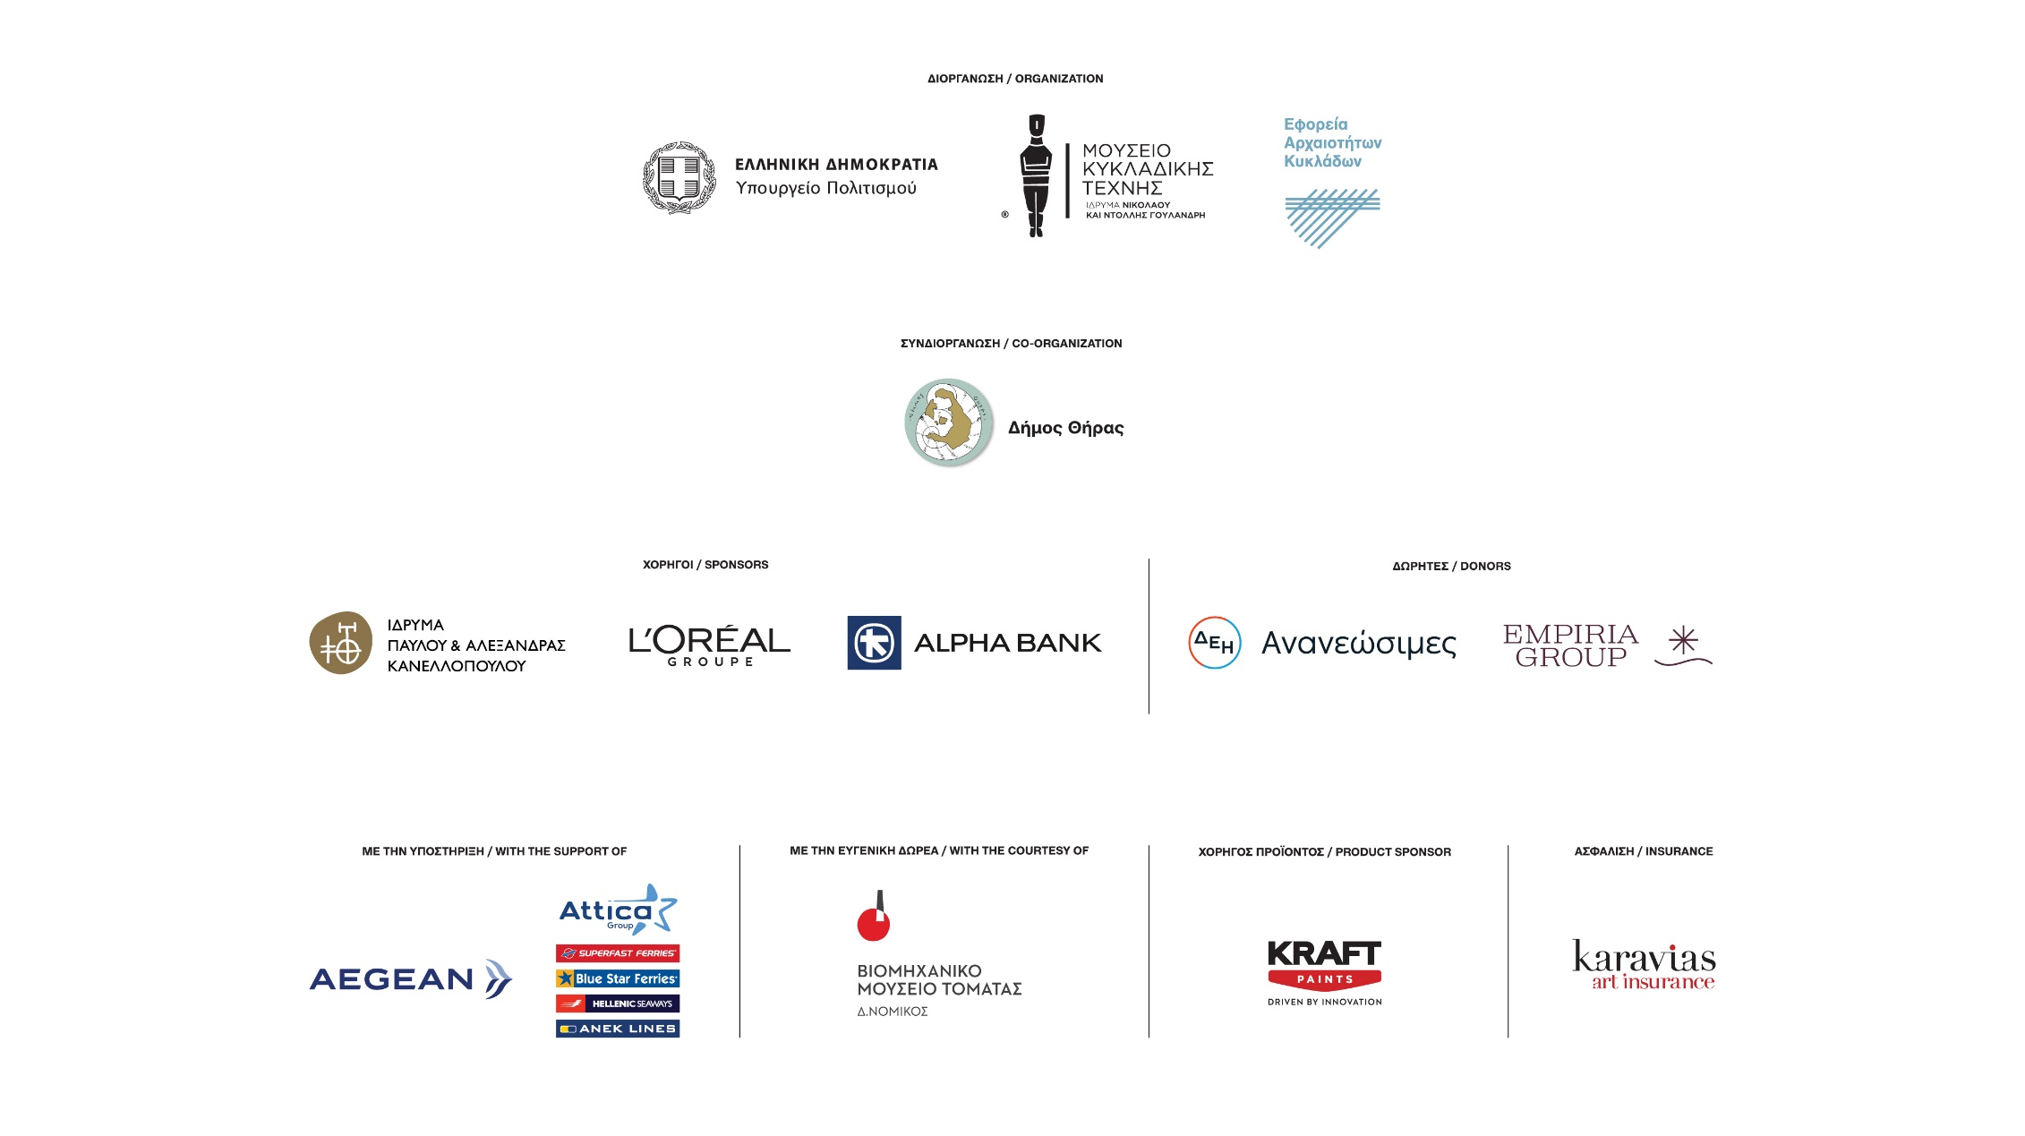[**https://www.youtube.com/shorts/uV4_z0s6clI**](https://www.youtube.com/shorts/uV4_z0s6clI)[**https://www.youtube.com/shorts/j0sZYd7OlJw**](https://www.youtube.com/shorts/j0sZYd7OlJw)